JalDrishti Software & Dashboard Specification

1. Problem statement
SIH26255 (Ministry of Jal Shakti) asks for an AI/ML system that continuously checks whether every rural tap connection delivers enough safe water on time, raises alerts when it doesn't, and syncs the evidence to government records.
Under Jal Jeevan Mission, a tap counts as a Functional Household Tap Connection (FHTC) only if it gives at least 55 litres per person per day, on a fixed schedule, at BIS 10500 quality. Today this is checked through periodic surveys, not continuously.
- Only 76% of connections were fully functional in the 2024 national assessment of 19,812 villages (FHTC report).
- Over 92% of families were satisfied with quality, but only 76% of samples passed lab germ tests.
- The main causes of failure are pump breakdowns, damaged pipes and electricity problems.
- Every village water service area now gets a Sujal Gaon ID, called the Aadhaar of rural water (PIB, Dec 2025). Nothing yet proves, day to day, that the service behind the ID still works.
The seven required capabilities:
- AI/ML monitoring of tap functionality at Gram Panchayat and household level.
- Real-time alerts for supply breaks, water-quality deterioration, low pressure, leaks and infrastructure failure.
- Citizen feedback with photos and geotags, in local languages.
- ML to detect abnormal patterns, predict failures and prioritise maintenance.
- Automatic sync with IMIS and Sujal Gaon IDs.
- GIS dashboards at multiple administrative levels.
- Scalability, interoperability and data security.

2. Solution in brief
JalDrishti measures a few points in each village, uses physics-guided AI to estimate supply and contamination risk at every household, blocks repair closure without proof, and syncs daily results to IMIS and the Sujal Gaon ID.
Layer | What happens | Where it shows in the software
Sense | 5–8 full nodes (pump, tank, pipeline), ~20 sentinel pressure loggers at tail-end taps, a QR plate on every tap | Node map, live telemetry, node health
Infer | Pipe-network twin and GNN estimate pressure and litres per person per day for every home; contamination risk index; pump fault diagnosis; repair priority | Household click panel, risk heatmap, maintenance queue
Prove | Daily Pramaan Score per home; 3-proof closure lock; tamper-evident hash-chained log | Repair Kanban, household register, audit log
Sync | Adapters to IMIS, WQMIS and Sujal Gaon ID; SMS and IVR alerts in local languages | Sync status page, alert previews
The five features the software must make visible:
- Pressure reads quality. Low pressure lets dirty water seep in, so pressure drives a contamination risk score per tap.
- Every home estimated. Each household shows estimated pressure and water quantity, labelled measured or estimated with a confidence %.
- Pump as a sensor. Pump current and voltage give flow and the cause of an outage: power cut, dry borewell or pump wear.
- One tap, one QR. Citizens report problems by scanning the tap's QR; Jal Sakhis photograph test strips beside it.
- No proof, no closure. A repair closes only after a verified photo, 45 minutes of pressure recovery and confirmation from affected families.
Demo assumption for all screens: one village of 400 households in three zones (A, B, C), one borewell pump and one overhead tank.

3. Users and roles
Six kinds of users share one data set; each sees only the screens for their job.
User | What they need | Main screens | Device
State / district official (PHED, DDWS) | Functionality across many villages, worst areas first | 1 Overview, 7 Register, 10 Sync and audit | Desktop
Assistant Engineer (block) | Escalated repairs, village detail, failure predictions | 2 Twin, 5 Alerts, 6 Kanban, 8 Failure prediction | Desktop
Gram Panchayat / VWSC | Daily village status and public proof | 1 Overview (village level), 15 Public proof | Desktop, tablet, Panchayat TV
Nal Jal Mitra (village technician) | Ranked repair tasks, fault diagnosis, photo proof | 12 Repair tasks | Mobile
Jal Sakhi (FTK tester) | Which taps to test, strip reading, payment status | 13 Routed tests | Mobile
Household | Tap status, alerts, a way to complain | 14 Tap QR page, SMS/IVR | Phone browser or missed call

4. App structure and look
Three front ends share one data model: an admin web dashboard with 11 screens, a field app with 2 and citizen pages with 2, plus a demo control panel that drives the simulator.
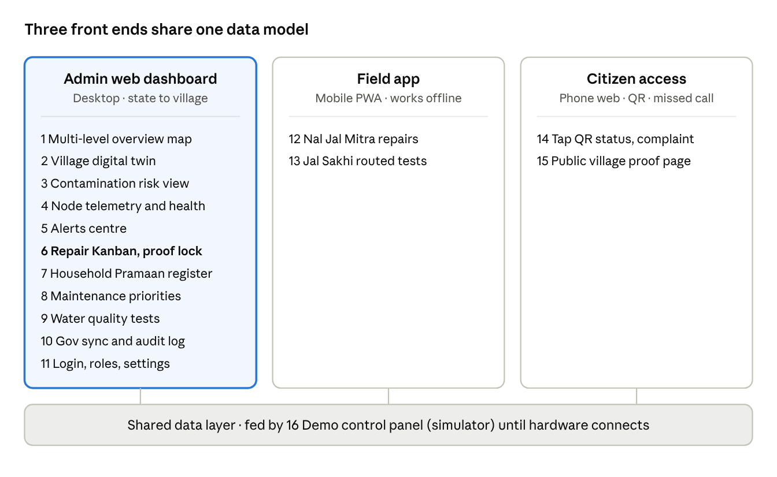
JalDrishti screen map · 3 front ends + demo panel, 16 screens
The admin dashboard is the main build; the field and citizen screens are small mobile views on the same data.
Global layout of the admin dashboard:
- Left sidebar: JalDrishti logo, then nav groups Monitor (Overview, Village twin, Risk, Telemetry, Alerts), Act (Repairs, Failure prediction, Tests), Prove (Household register, Sync and audit), Settings, and a hidden Demo control panel.
- Top bar: level selector (State › District › Block › Gram Panchayat › Village), search by Sujal Gaon ID, household ID or ticket ID, date picker, language switch, alerts bell with count, user role chip.
- Content area: white cards on a light grey background; maps run full width where used.
- Mobile screens: single column, bottom tab bar, large tap targets, local language first (English and Hindi at minimum, plus the state's language).
Token | Value | Meaning on every screen
Navy | #1F3864 | Sidebar, headers
Blue | #0070C0 | Primary buttons, links, selected items
Orange | #F7941D | Highlights, priority, key numbers
Green | #1E9E4A | Functional, online, proof passed
Amber | #F2A900 | Warning, at risk, stale data
Red | #D93025 | Failure, high risk, overdue
Grey | #8A94A6 | Offline, not yet checked
Background | #F5F7FA | Page background; cards white with 8 px corners
Type: Inter or Arial; KPI numbers 28–32 px bold, body 14 px. Status colours always mean the same thing, so a red dot on the map and a red card on the Kanban both mean failure.

5. Screen-by-screen features
Sixteen screens: fifteen across three front ends plus a demo control panel; screens 2, 3, 6 and 13 carry the core idea and should look the most finished.

5.1 Admin web dashboard (desktop)
Screen 1 · Multi-level overview (home)
- Purpose: see tap functionality from State down to one village.
- Layout: KPI row of 5 cards on top; map on the left (about 65%); ranked worst-areas list and live alert feed on the right.
- KPI cards: % households fully functional today, households estimated today, open tickets (overdue in red), high-risk taps, median repair time.
- Map: breadcrumb State › District › Block › Gram Panchayat › Village; areas coloured by functional % (default bands: green 90%+, amber 75–90%, red below 75%); click drills one level down; at village level it opens Screen 2.
- Filters: date, zone, scheme, fault type. Export: monthly block and district report (PDF, CSV) and a one-page Gram Sabha summary.
Screen 2 · Village digital twin
- Purpose: one village's pipes, sensors and every house on one map.
- Layout: full-width map, layer toggles top-left, 24-hour time slider at the bottom, detail drawer on the right.
- Layers: pipe network, nodes (pump, tank, pipe, sentinel icons with a status ring), households as dots coloured by today's Pramaan Score, risk heatmap, toilets and drains.
- Click a household: IMIS household ID, Sujal Gaon ID, zone; estimated pressure (kPa) and litres per person per day; supply hours vs schedule; badge "Measured" or "Estimated · 87% confidence"; risk level; last test result and date; open tickets; 7-day mini chart; a "why this estimate" line naming the nearest sensors used and the last bucket calibration.
- Click a node: its live readings, with a link to Screen 4.
- Time slider replays the last 24 hours as colours change.
Screen 3 · Contamination risk
- Purpose: show where dirty water may be entering and what was done about it.
- Layout: risk heatmap map on the left (about 60%); ranked list of high-risk taps on the right.
- Each tap entry: tap ID, risk score 0–100, three breakdown bars (Hazard: minutes below 70 kPa, pressure spikes, supply restarts · Vulnerability: distance to toilets and drains, pipe age · Barrier: chlorine proxy from tank ORP and pH).
- Actions log: "Jal Sakhi routed to tap B-217", "First-flush advisory sent to 38 homes".
- Show risk level and test result separately; never label water safe or unsafe.
Screen 4 · Node telemetry and health
- Purpose: live readings and health of every sensor.
- Layout: grid of node cards; a card opens a detail page with charts.
- Pump node: voltage, current, delivery pressure, borewell level, estimated flow (m³/h), runtime, diagnosis label (Running, Power cut, Source dry, Pump wear, Dry-run).
- Tank node: level, pH, ORP, conductivity, turbidity, last cleaning, drift warning.
- Pipe and sentinel nodes: pressure line chart with a dashed 70 kPa line, burst events marked, battery %, LoRa signal, last seen, days of offline storage used.
- Status ring: green online, amber stale, grey offline.
Screen 5 · Alerts centre
- Purpose: one feed of everything that went wrong.
- Layout: filter bar, alert feed, detail drawer.
- Alert types: supply outage, low pressure, contamination risk, leak or burst, pump fault, power cut, source dry, node offline, probe drift, citizen complaint (voice notes transcribed and translated by Bhashini).
- Each alert: time, village and zone, severity, households affected, root cause, channels sent (SMS, IVR, languages) with the full message text, linked ticket.
Screen 6 · Repair Kanban with proof lock
- Purpose: track repairs and block closure without evidence.
- Columns: New → Assigned → In repair → Awaiting proof → Closed, plus an Escalated lane.
- Card: ticket ID, source (sensor, citizen or test), village and zone, AI diagnosis, households affected, critical sites (school, anganwadi, health centre), priority score, SLA countdown, assigned Nal Jal Mitra, and a truth score (0–100) showing how strongly sensors, complaints and tests agree the fault is real.
- Ticket detail shows the priority breakdown (households affected × hours without water × contamination risk × critical sites) and three proof checks, each grey, amber or green:
  - Repair photo: GPS near the fault, taken after the ticket opened, not a reused image.
  - Pressure recovery: 45 minutes at 70 kPa or more, or at 85% or more of that sensor's normal level, with a mini chart and progress bar.
  - Family confirmation: IVR calls to randomly chosen affected households, shown as "2 of 3 confirmed".
- "Mark resolved" stays disabled until all three are green; dragging a card to Closed early bounces it back with a message naming the missing proof.
- A missed SLA moves the card to Escalated and notifies the Assistant Engineer.
Screen 7 · Household Pramaan register
- Purpose: the daily score for every household and the village roll-up.
- Layout: village header card (Pramaan Score, integrity flag green / amber / red on the Sujal Gaon ID); household table below.
- Columns: household ID, zone, Quantity (litres per person per day vs 55), Regularity (hours vs schedule), Quality (risk and last test), daily score, 7-day trend, measured / estimated badge.
- Names masked by default; CSV export.
Screen 8 · Failure prediction
- Purpose: warn about failures before they happen; ranking repairs stays on Screen 6.
- Layout: pump health on the left, weak pipe sections on the right.
- Pump health: current vs estimated flow over time, with a wear warning when the ratio drifts.
- Weak sections: pipe segments with repeated low-pressure or burst events, on a mini map.
- Each warning has a "Create ticket" button that sends it to Screen 6.
Screen 9 · Water quality tests
- Purpose: track Jal Sakhi tests and their payments.
- Layout: filterable table with a photo thumbnail column.
- Columns: date, tap ID, tester, parameters tested, AI strip reading, verified status, WQMIS upload status, payment status (Payment-ready, Released via PFMS).
Screen 10 · Gov sync and audit log
- Purpose: show what reached government systems and prove records were not altered.
- Sync panel per system (IMIS, WQMIS, Sujal Gaon): last sync, records sent, pending, failed, reconciliation %.
- Audit log: one row per day with record count, daily hash and previous hash; a "Verify chain" button that rechecks and shows a tick.
- Public proof: generate today's QR for the Panchayat notice board.
Screen 11 · Login, roles and settings
- Login by phone OTP or username, with a role picker for the demo (State official, Assistant Engineer, Gram Panchayat, Nal Jal Mitra, Jal Sakhi); each role lands on its own home screen. Roles and permissions, villages and zones, thresholds (70 kPa, 85% baseline, 45-minute recovery, SLA hours), alert languages, data retention, privacy (phone numbers masked, consent recorded for SMS and IVR, a log of who viewed household data).

5.2 Field app (mobile PWA, works offline)
Screen 12 · Nal Jal Mitra repair tasks
- Bottom tabs: Tasks, Map, Profile; an offline badge counting items not yet synced.
- Task list sorted by priority, each with an SLA timer chip.
- Task detail: diagnosis ("Pump fault: normal voltage, low current"), households affected, map route to the fault.
- Repair photo capture with automatic GPS and time stamp.
- "Request closure" moves the ticket to Awaiting proof and shows the three proof checks filling in.
Screen 13 · Jal Sakhi routed tests
- Today's list ranked by risk, e.g. "Tap B-217 · high risk · test after supply restart".
- Scan the tap QR to confirm the tap ID.
- Camera screen with a frame guide to place the strip beside the plate's colour patches.
- Result screen: AI-read values with confidence, a retake button, "Submit to WQMIS".
- Success banner "Verified · Payment-ready"; an earnings tab with the status of each test; a monthly 10-litre bucket-test task that calibrates household estimates.

5.3 Citizen access
Screen 14 · Tap QR page (opens on scan, no login)
- Header: tap ID, village, Sujal Gaon ID, language picker.
- Today's status card: "Water supplied today 6:00–8:00", next supply time, and "No risk signals today · next test due 24 Oct".
- Report a problem: chips (No water, Low pressure, Dirty water, Leak, Other), photo, voice note (Bhashini), automatic GPS; submit returns a ticket number to track.
- Missed-call number printed for basic phones.
Screen 15 · Public village proof page
- Today's village Pramaan Score and 30-day trend, the integrity flag, tickets opened and closed this week, today's audit QR and hash.
- Large-type mode for a Panchayat TV.

5.4 Demo control panel (simulator)
Screen 16 · Demo control panel
- A hidden admin page that drives the simulator: it writes mock readings into the same data layer real sensors will use, so the dashboard does not change when hardware connects.
- Scenario buttons: pump fault in Zone B, low-pressure event, contamination risk spike, node offline, a reused repair photo (the lock rejects it), family confirmations arriving.
- A reset button returns the village to normal; every screen shows a "Simulated data" tag while the simulator is the source.
- Message preview: the SMS and IVR scripts each scenario sends, by language.

6. Mock data model
Nine entities feed every screen; build them as mock JSON first so the front end can run before any backend exists.
Entity | Key fields
Village | sujal_gaon_id, name, district, block, gram_panchayat, households, zones, pramaan_score, integrity_flag
Node | node_id, type (pump, tank, pipe, sentinel), lat, lng, zone, status, battery_pct, signal, last_seen, buffer_days_used
Reading | node_id, timestamp, pressure_kpa, current_a, voltage_v, flow_m3h, ph, orp_mv, ec, turbidity_ntu, tank_level_pct
Household | imis_hh_id, zone, lat, lng, members, est_pressure_kpa, est_lpcd, supply_hours, confidence_pct, source (measured, estimated), risk_score, last_test_id, daily_score
Ticket | ticket_id, type, diagnosis, zone, households_affected, critical_sites, priority, status, sla_due, assignee, proof_photo, proof_pressure, proof_families
Test | test_id, tap_id, tester, timestamp, parameters, ai_reading, confidence_pct, verified, wqmis_status, payment_status
Alert | alert_id, type, severity, zone, households_affected, root_cause, channels, languages, ticket_id
AuditDay | date, record_count, daily_hash, prev_hash
SyncStatus | system (IMIS, WQMIS, Sujal Gaon), last_sync, sent, pending, failed
Suggested demo village state, so every screen has something to show:
- 400 households: Zone A 150, Zone B 140, Zone C 110.
- Nodes: S1 pump, S2 tank, S3–S5 pipeline, T1–T20 sentinels.
- Pressure: 110–130 kPa near the tank, 75–95 kPa at tail ends on a normal day.
- One live outage in Zone B (pump fault at 06:10), 12 high-risk taps, 6 open tickets (1 escalated, 1 awaiting proof).
- About 25 taps measured directly by nodes and sentinels; the rest estimated, with monthly bucket calibration.
Sample household rows:
imis_hh_id,zone,members,est_pressure_kpa,est_lpcd,supply_hours,confidence_pct,source,risk_score,daily_score
HH-A-0012,A,5,118,62,2.0,94,measured,12,96
HH-B-0217,B,6,4,0,0.0,88,estimated,81,22
HH-B-0221,B,4,58,41,1.2,83,estimated,67,54
HH-C-0309,C,5,86,57,1.8,90,estimated,24,88

7. Wording rules and build order
Build the proof-lock Kanban first; it is the most distinctive screen and the easiest to make fully working.
Wording rules for every screen and message:
- Never say "safe to drink". Use "No risk signals today · next test due [date]".
- Every household value carries a "Measured" or "Estimated · n% confidence" badge.
- Avoid "exact", "impossible" and "blockchain"; say "tamper-evident log".
- Use the official names: Nal Jal Mitra, Jal Sakhi, Sujal Gaon ID, IMIS, WQMIS.
- Mark mock data with a small "Simulated data" tag on screens that show it.
Build order:
- Screen 6 · Repair Kanban with proof lock
- Screen 2 · Village digital twin with household click panel
- Screen 3 · Contamination risk
- Screen 1 · Multi-level overview
- Screen 13 · Jal Sakhi routed tests
- Screen 14 · Tap QR page
- Screen 10 · Gov sync and audit log
- All remaining screens (build Screen 16, the demo control panel, alongside step 1 so every scenario can be triggered live)
Suggested stack: keep the current Vercel site, or use React with Leaflet for maps and Chart.js for charts, reading from the mock JSON in section 6.

